Ssh service status in ubuntu
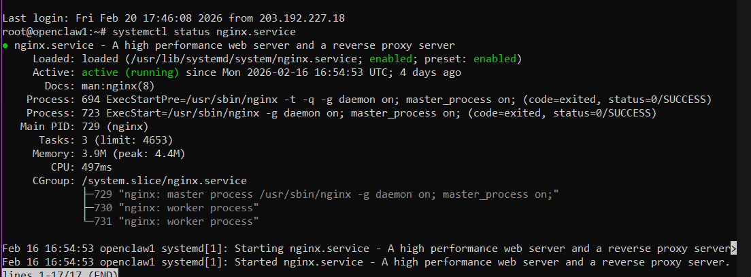
Nginx welcome page
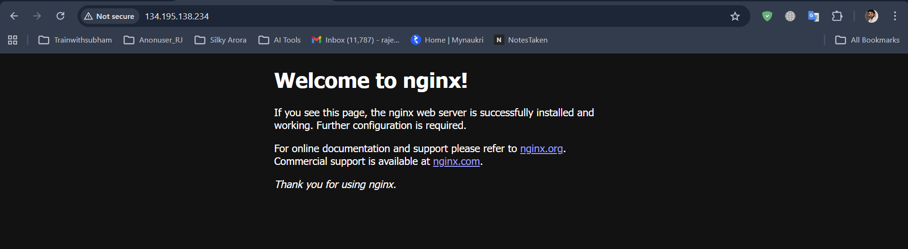
Nginx version
Nginx logs
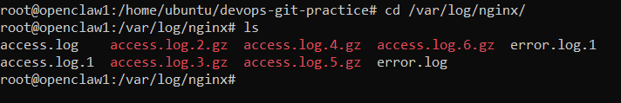
Docker installation –
Sudo apt install docker.io
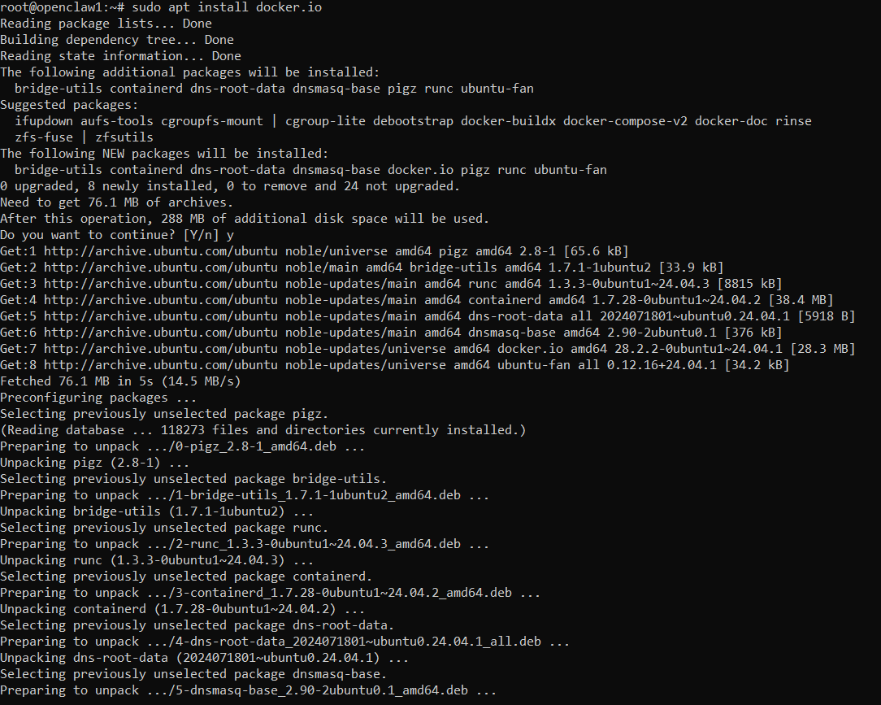
Docker service status
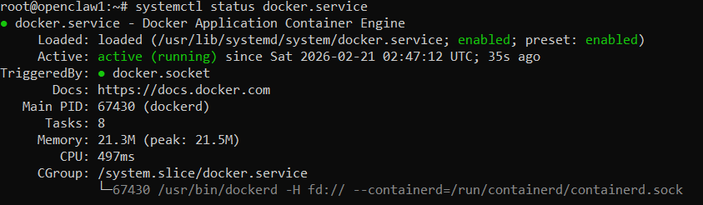
Docker version -
Docker service log –
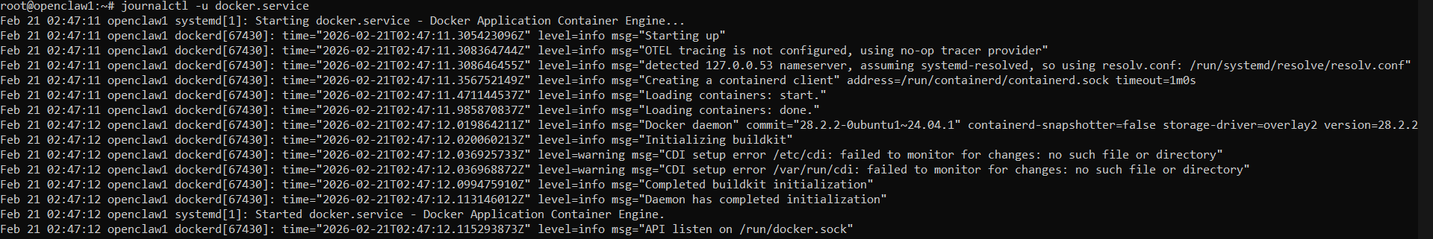
Docker version
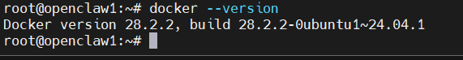

# Day 08 – Cloud Server Setup: Docker, Nginx & Web Deployment
## Commands Used
# Update system packages
sudo apt-get update
sudo apt-get upgrade -y
# Check nginx service status
systemctl status nginx.service
# Check docker service status
systemctl status docker
# Verify installed versions
nginx -v
docker --version
# View docker service logs
journalctl -u docker.service
# View nginx logs
sudo cat /var/log/nginx/access.log
sudo cat /var/log/nginx/error.log
# Save logs to a file
sudo cat /var/log/nginx/access.log > ~/nginx-logs.txt
# Transfer logs to local machine (from local system)
scp -i your-key.pem ubuntu@<your-instance-ip>:~/nginx-logs.txt .

